Lesson 8 consuming multiple contexts

<https://www.youtube.com/watch?v=hLFl4Io0mww&list=PL4cUxeGkcC9hNokByJilPg5g9m2APUePI&index=8>

So far have seen 2 ways to consume

Static 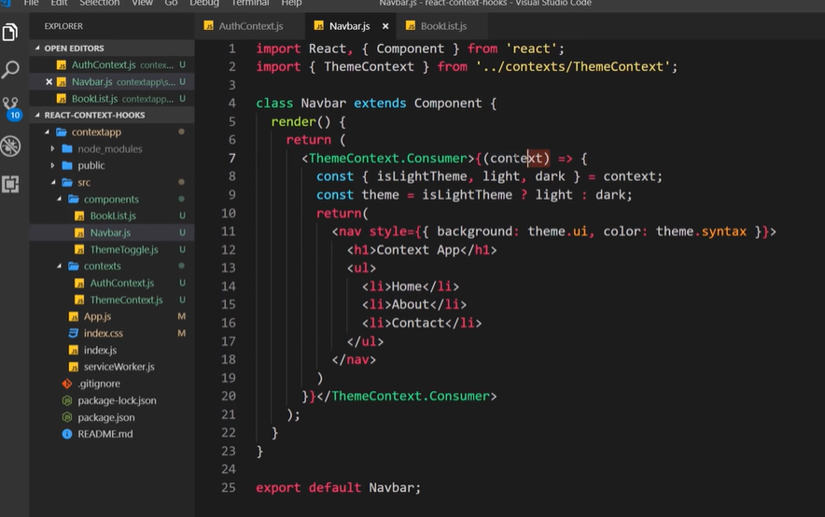

Getting context object from function

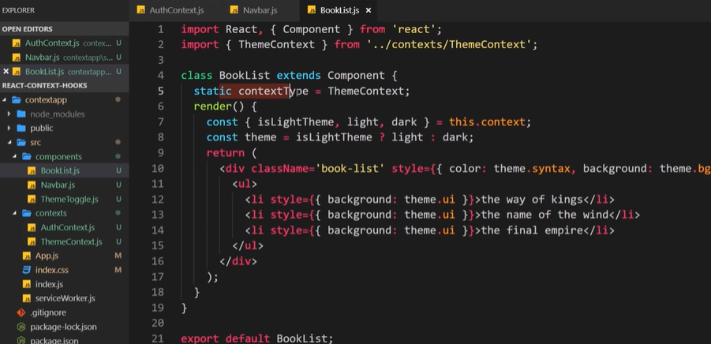

This will not work cannot have 2 static contexts with the same name

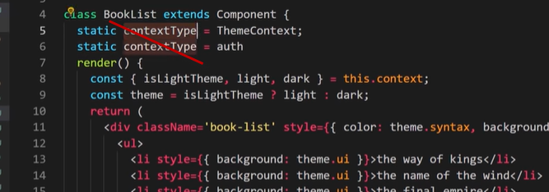

Nest using 2 consumer tags , surround ThemeContext.Consumer with AuthContext.Consumer 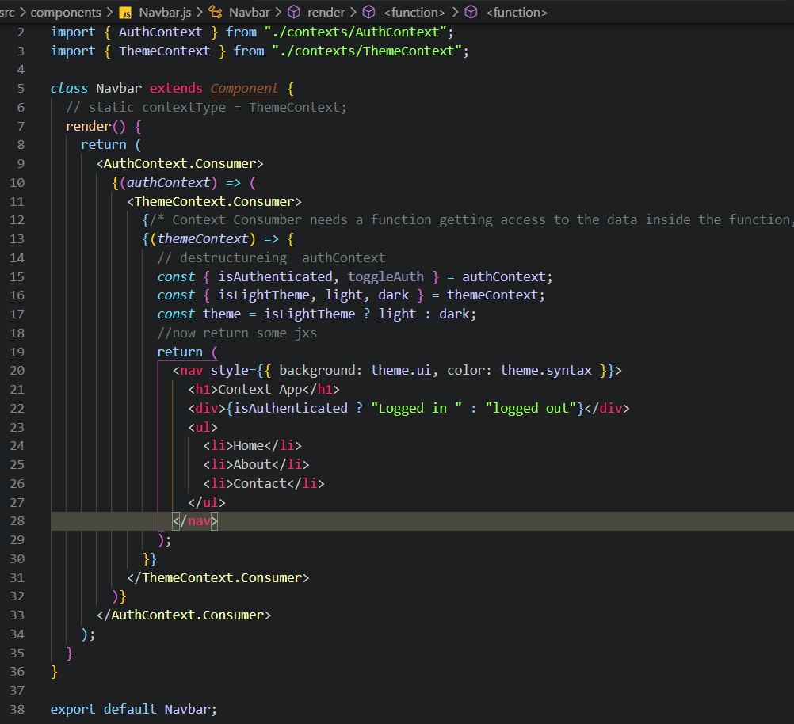

**There is a better way to do this using hooks**